# Install Indicator

1. Copy file ATRForTralingStop.afl to C:\Program Files\AmiBroker\Formulas\Include
2. Copy file AtrTrailX.afl and BackTest_ATRTrail_Tfex to

C:\Program Files\AmiBroker\Formulas\Custom

1. Refresh folder

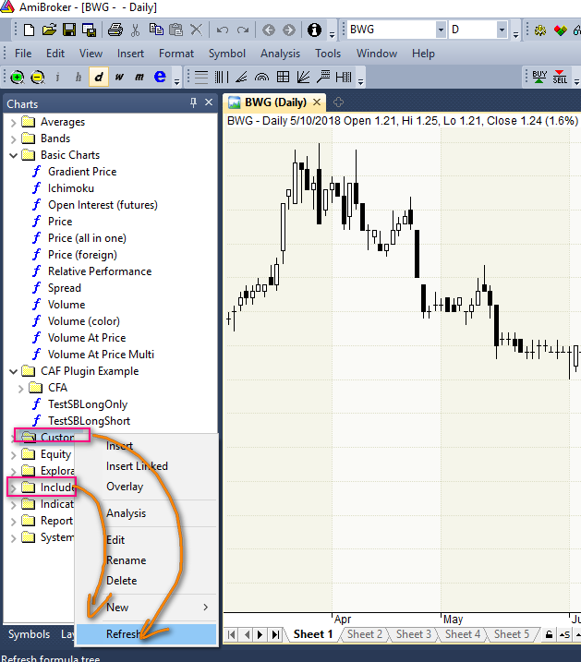

# Test Plot Indicator

3.Test plot indicator

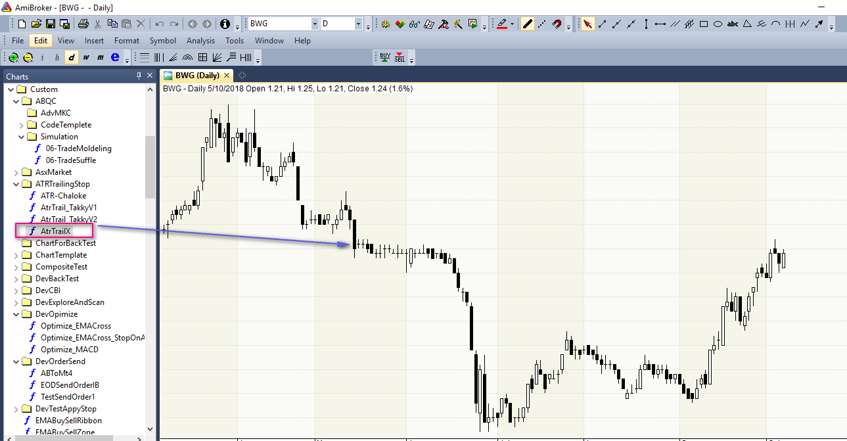

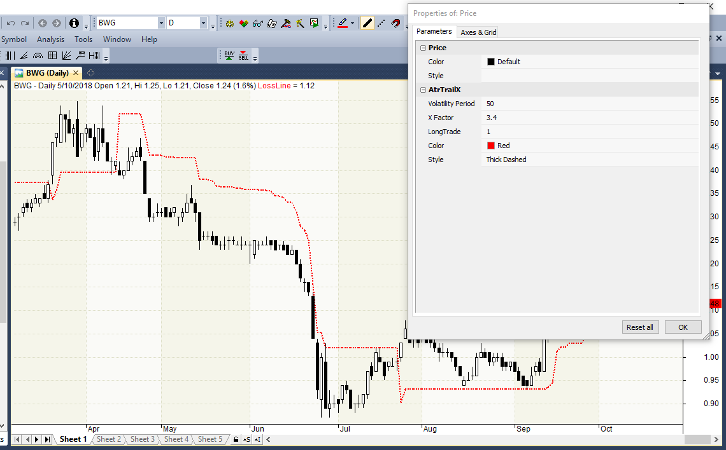

# BAckTEst

4.Run BackTest

1. News analysis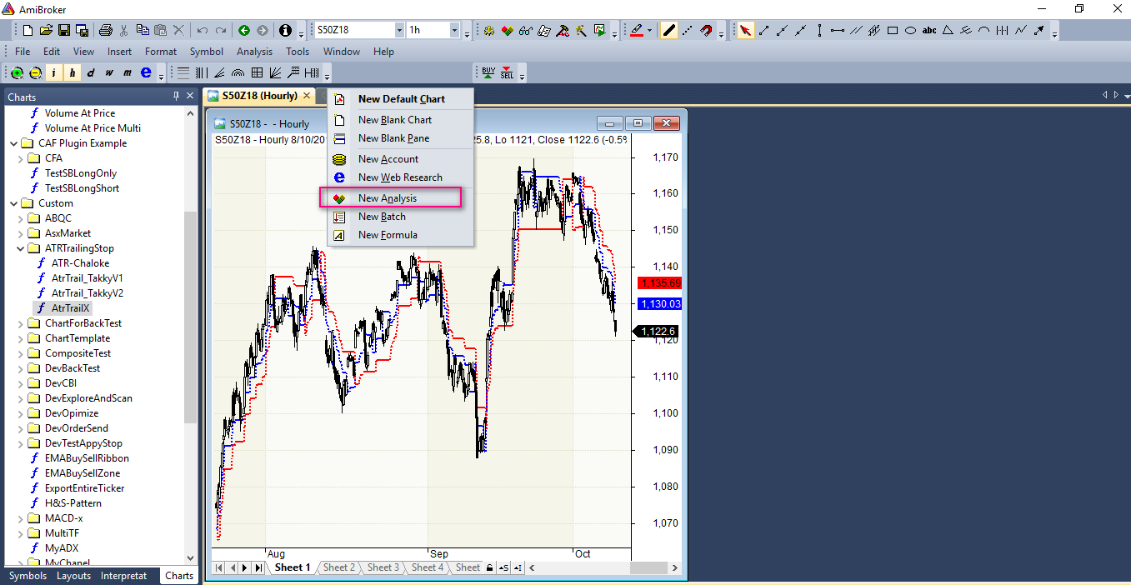

2.open backtest file

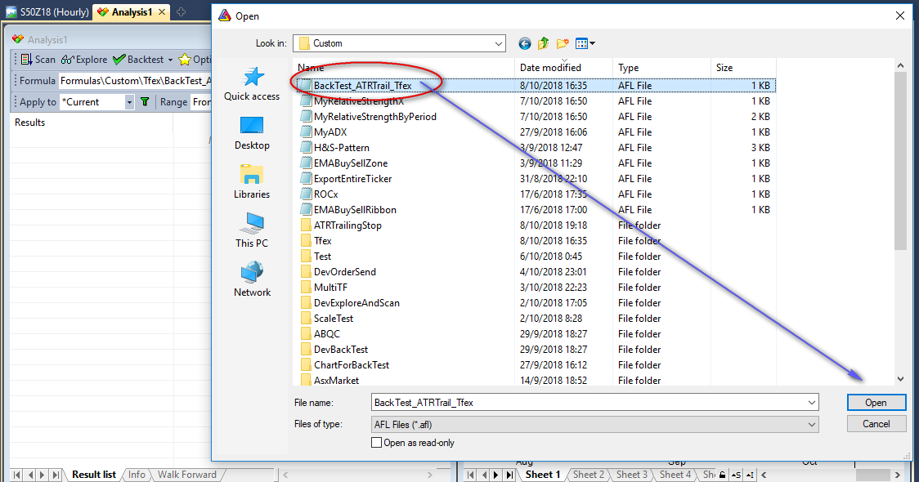

3.change preferred time period to test

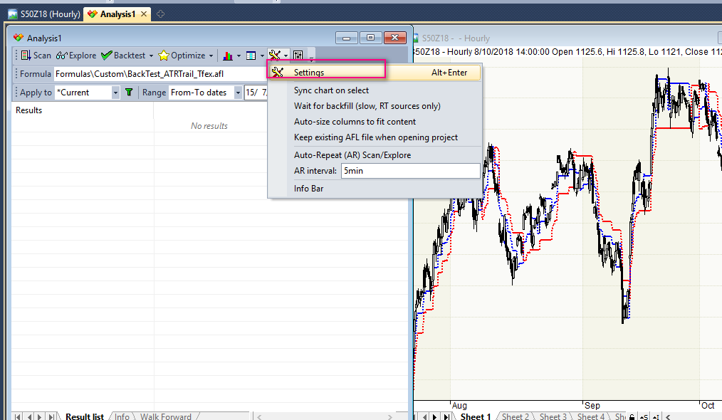

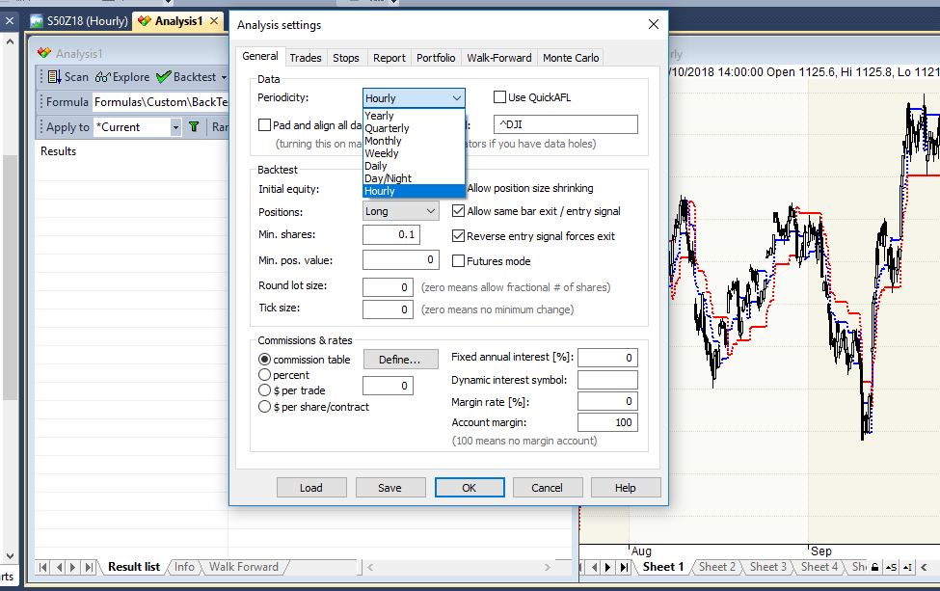

4.apply to current symbol and specify range (start to end ) to test

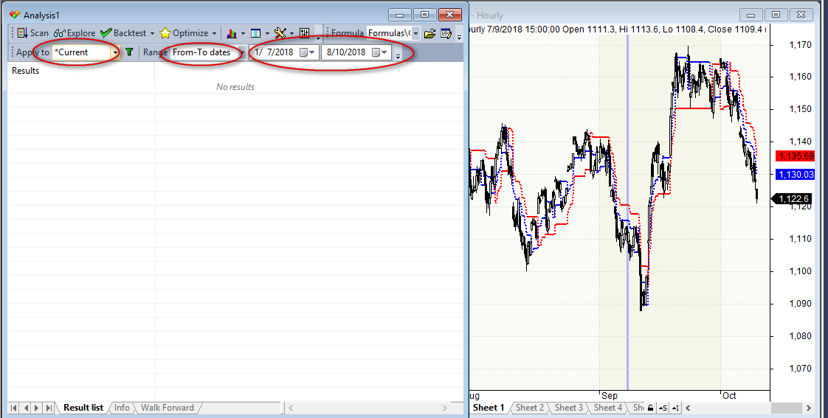

5.click backtest

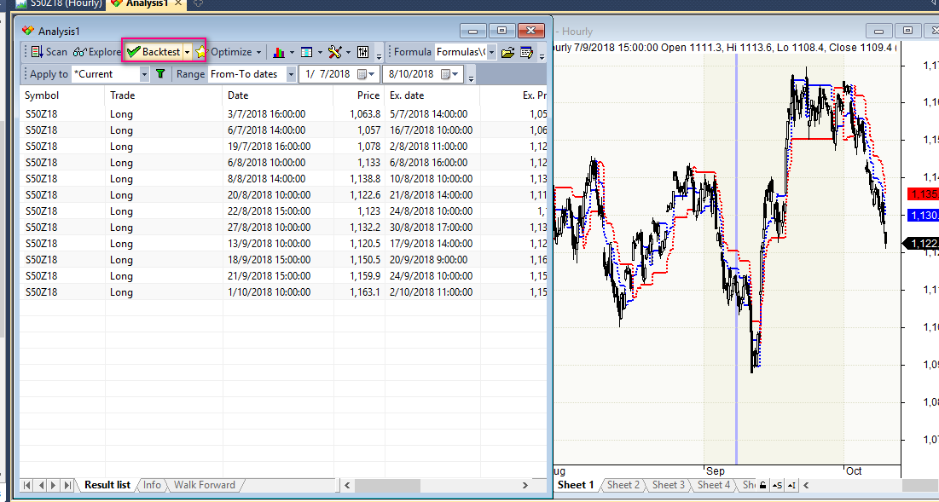

6. click “show arrow for actual traded”in order to show buy/sell arrow while running backtest

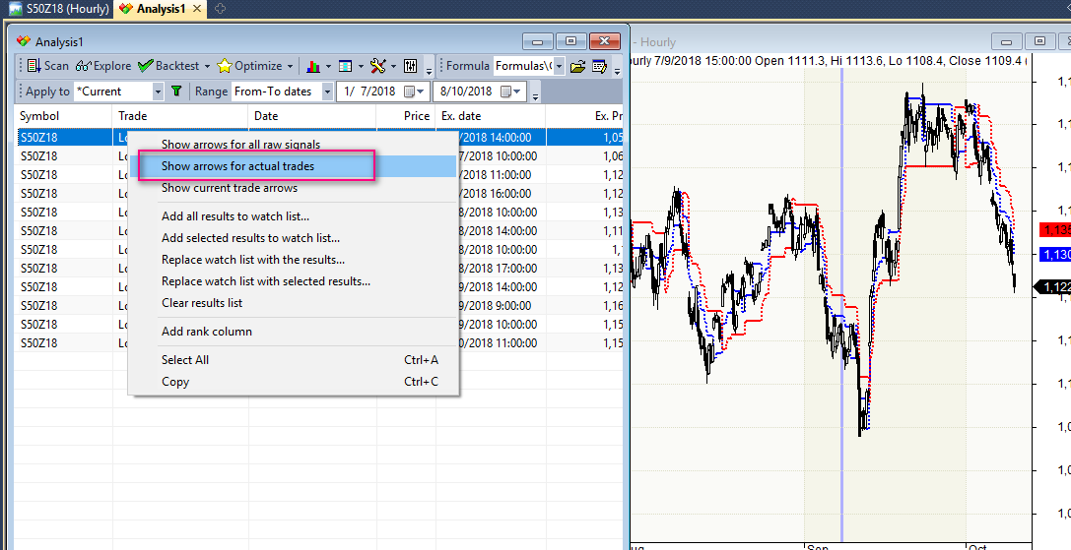

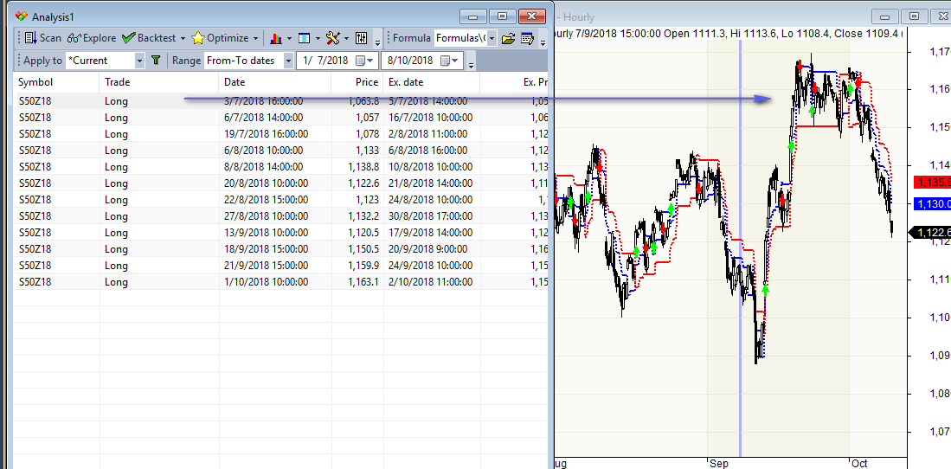

7.view test result

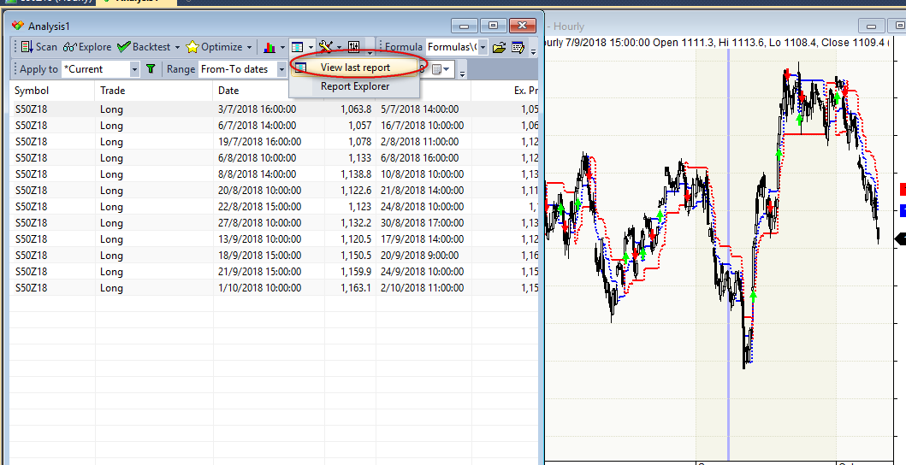

7.1 view statistic

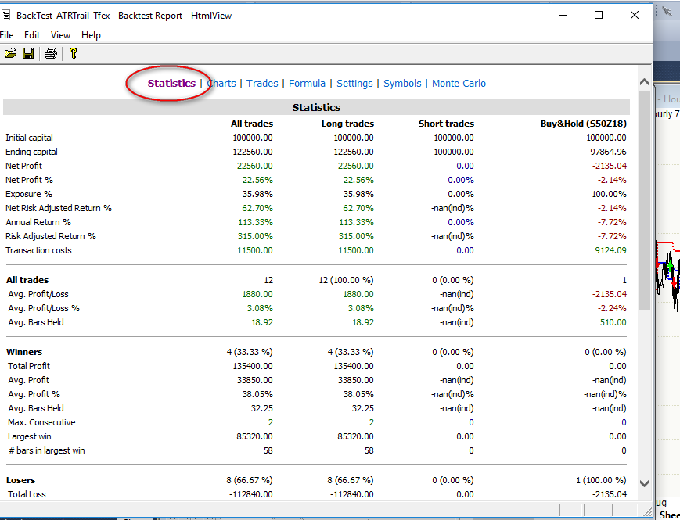

7.2 view chart

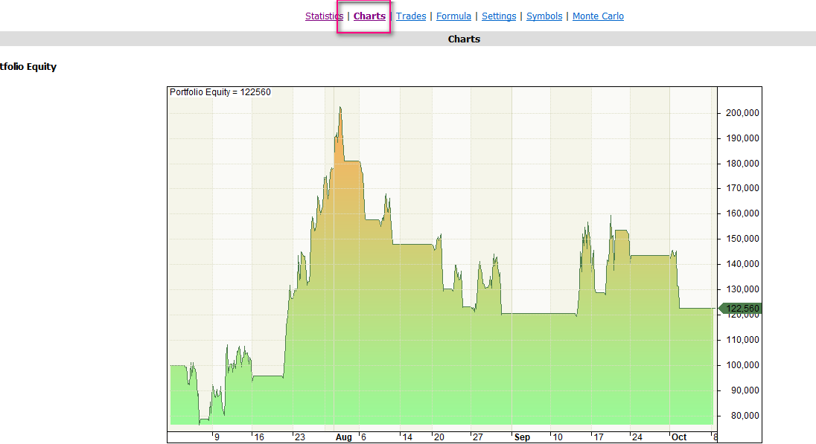

# Modify Backtest

8. Modify bakctest file

8.1edit code as desired.

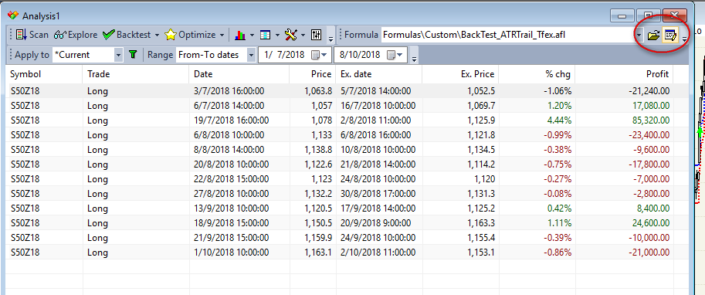

8.2 You can change what you want at here

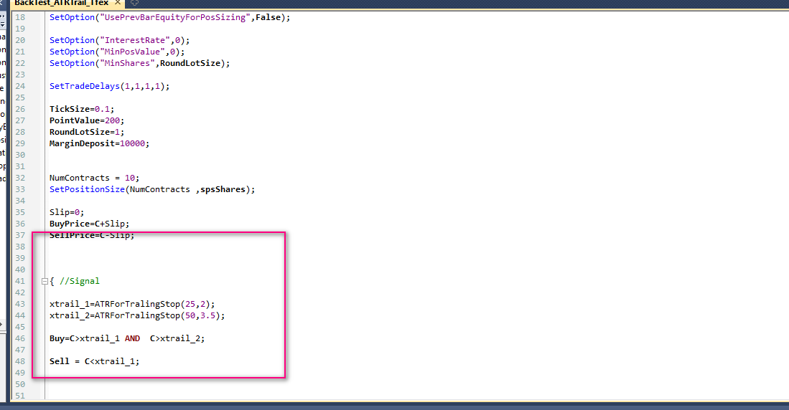

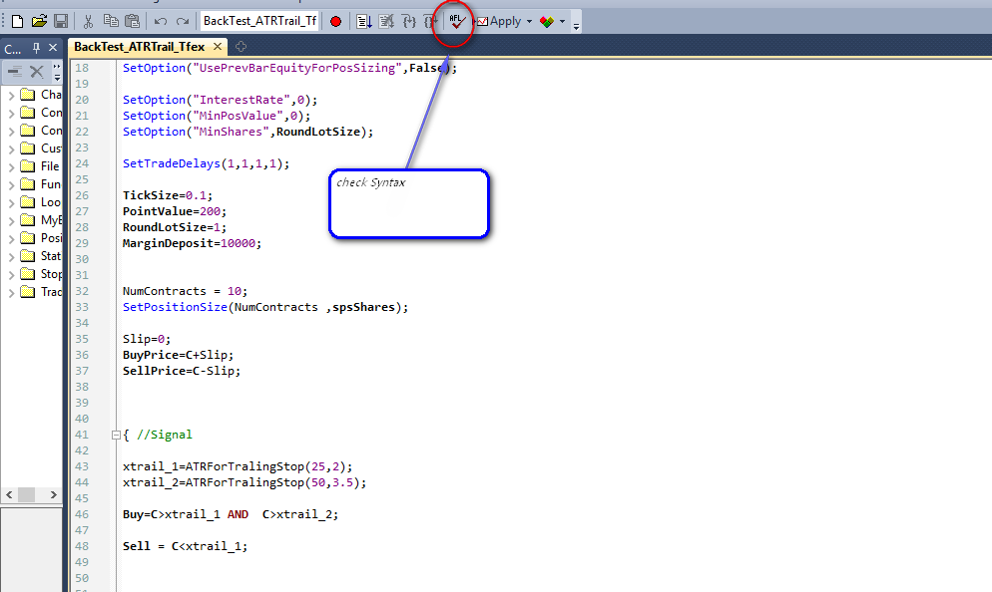

8.3 When you modify completely, sent backtest to analyst again

